**Mining Big Datasets**

**Group Assignment**

**Team Members**

**Meropi Maria Argyropoulou (BAFT 1722)**

**Lila Tsopelakou (BAFT 1716)**

**Lisa Schramm (BAFT 1701)**

Contents

1. Neo4J Assignment 3

1.1. Data Model 3

1.2. Parsing the files 5

1.3. Importing the files into Neo4J 6

1.4. Cypher Queries 8

Tables

Table 1:csv files 5

Table 2: Import Commands 6

Table 3: Query 1 8

Table 4: Results Query 1 8

Table 5:Query 2 9

Table 6: Results Query 2 9

Table 7: Query 3 10

Table 8: Results Query 3 10

Table 9: Query 4 11

Table 10: Results Query 4 11

Table 11: Query 5 12

Table 12: Results Query 5 12

Table 13: Query 6 14

Table 14: Query 7 16

Table 15: Results Query 7 16

Images

Image 1: High Level Data Model 3

Image 2: Example based on the Data Model 4

Image 3: Screenshot Query 1 8

Image 4: Screenshot Query 2 9

Image 5: Screenshot Query 3 10

Image 6: Screenshot Query 4 11

Image 7: Names of players 13

Image 8: Screenshot Query 5 13

Image 9: Graph of Game 636 14

Image 10: Game 636 zoomed 15

# Neo4J Assignment

* 1. Data Model

The file that we were given in the context of this assignment contains the data from 684 chess games played in world chess tournaments. More specifically, the file includes the players' details, the tournaments, the date, the result of the game, as well as all the moves of each game and the positions that occur in the chessboard with each move. To model the data as a property graph and answer queries based on it, we decided to create four basic nodes Player, Game, Event and Position and for relationships among them as depicted in the Image 1 (between Player-Game, Game-Event, Game-Position for the 1st move and transition from a Position to Position for the rest of the moves). In addition, we put the information of the Gamenumber as a property of the move in order to know the game number that this specific move was played, which will later help us run the queries.

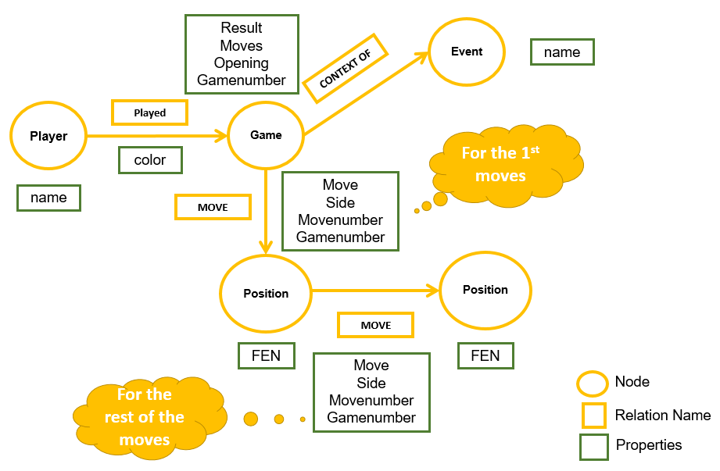

**Image 1: High Level Data Model**

Additionally, based on the aforementioned data model, we created an example with data illustrated on Image 2.

In the next sections, we explain how we parsed the data from the initial file provided *chessData.txt*, imported them in the neo4j graph database and wrote and executed queries in cypher language on them.

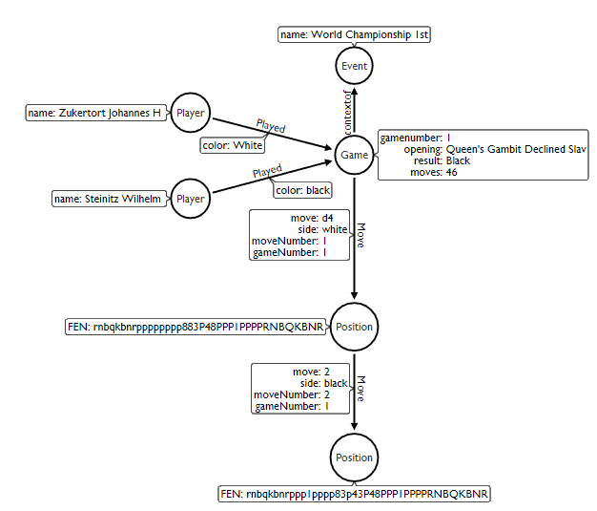

**Image 2: Example based on the Data Model**

* 1. Parsing the files

We created a program in R programming language which reads line by line the chessData.txt file and based on the split lines:

* "===========================Game======================================================",
* "--------------------------------------------------------- Game Moves ---------------------------------------------------------------------" and
* "======================================================================================",

creates two new files, one containing the game details (*output.txt*) and one the moves information per game (*outputmoves.txt*).

Afterwards we wanted to transform our data to dataframes. In consequence we performed the following modifications:

* Dataframe games:

For the game details we read the lines of the *output.txt* document and split by “:” the line in two columns. Because we wanted to make column names the Black, BlackElo, Date, ECO, Event, EventDate, GameNumber, HalfMoves, Moves, Opening, Result, Round, Site, White, WhiteElo we used *tidyr* and *purrr* packages to map the values of column 1 tp the values of column 2 and transform them then into a dataframe.

* Dataframe moves:

For the move details we read the lines and trimmed the names of each line (*sub() function*). Then we put the names as columns creating that way a dataframe.

Based on the data model explained above, we created 8 csv files, depicted in Table 1 before importing them to Neo4J.

**Table 1:csv files**

|  |  |  |  |
| --- | --- | --- | --- |
| Names | Description | csv file | Details |
| Player | Node | player.csv | Distinct player names |
| Game | Node | game.csv | Distinct games |
| Position | Node | position.csv | Distinct positions |
| Event | Node | event.csv | Distinct events |
| Played | Relationship between Player-Game | rpg.csv | Data of the relationship |
| Move | Relationship between Game-Position | rgpos.csv | Data of the relationship |
| Move | Relationship between Position-Position | rpospos.csv | Data of the relationship |
| ContextOf | Relationship between Game-Event | reg.csv | Data of the relationship |

* 1. Importing the files into Neo4J

The code that follows includes all the statements that were executed to import the data into the Neo4J and create the respective graph data model. We downloaded the neo4j-community-3.4.1 version and making our machine a server, we connected to <http://localhost:7474/browser/> and executed the commands.

**Table 2: Import Commands**

|  |
| --- |
| // Create node game  **USING PERIODIC COMMIT**  **LOAD CSV WITH HEADERS FROM** "file:///game.csv" **AS** row  **CREATE** (:Game {gameNumber: TOINT(row.GameNumber), moves: row.Moves, opening: row.Opening, result: row.Result});  // Create node event  **USING PERIODIC COMMIT**  **LOAD CSV WITH HEADERS FROM** "file:///event.csv" **AS** row  **CREATE** (:Event {event: row.Event});  // Create node player  **USING PERIODIC COMMIT**  **LOAD CSV WITH HEADERS FROM** "file:///player.csv" **AS** row  **CREATE** (:Player {name: row.Player});  //Creating indexes  **CREATE INDEX ON**:Game(gameNumber);  **CREATE INDEX ON**:Game(result);  **CREATE INDEX ON**:Player(name);  **CREATE INDEX ON**:Event(event);  // Create relationship between game and event  **USING PERIODIC COMMIT**  **LOAD CSV WITH HEADERS FROM** "file:///reg.csv" **AS** row  **MATCH** (game:Game {gameNumber: TOINT(row.GameNumber)})  **MATCH** (event:Event {event:row.Event})  **MERGE**(game)-[:CONTEXTOF]->(event)  // Create relationship between game and player  **USING PERIODIC COMMIT**  **LOAD CSV WITH HEADERS FROM** "file:///rpg.csv" **AS** row  **MATCH** (game:Game {gameNumber: TOINT(row.GameNumber)})  **MATCH** (player:Player {name:row.Player})  **MERGE**(player)-[:PLAYED{color: row.Color}]->(game)  // Create position  **USING PERIODIC COMMIT**  **LOAD CSV WITH HEADERS FROM** "file:///position.csv" **AS** row  **CREATE** (:Position {FEN: row.Position});  //Creating indexes  **CREATE INDEX ON**:Position(FEN);  // Create relationship between game and position  **USING PERIODIC COMMIT**  **LOAD CSV WITH HEADERS FROM** "file:///rgpos.csv" **AS** row  **MATCH** (game:Game {gameNumber: TOINT(row.GameNumber)})  **MATCH** (position:Position {FEN:row.FEN})  **MERGE**(game)-[:MOVE{gameNumber: TOINT(row.GameNumber), movenumber:row.MoveNumber, move:row.Move, side:row.Side}]->(position)  // Create relationship between position and position  **USING PERIODIC COMMIT**  **LOAD CSV WITH HEADERS FROM** "file:///rpospos.csv" **AS** row  **MATCH** (game:Game {gameNumber: TOINT(row.GameNumberBefore)})  **MATCH** (positionBefore:Position {FEN:row.FENBefore})  **MATCH** (positionAfter:Position {FEN:row.FENAfter})  **MERGE**(positionBefore)-[:MOVE{gameNumber: TOINT(row.GameNumberBefore), movenumber:row.MoveNumberAfter, move:row.MoveAfter, side:row.SideAfter}]->(positionAfter) |

* 1. Cypher Queries
* **Query 1:**

***In how many games (count) the position with FEN: r1bqkbnrpppp1ppp2n51B2p34P35N2PPPP1PPPRNBQK2R has appeared and what was the percentage that white wins.***

* + Cypher Query:

**Table 3: Query 1**

|  |
| --- |
| **MATCH** (g:Game)  **WHERE** (g.result='White')  **WITH** collect(g.gameNumber) as whitewinners  **MATCH** (n1:Position)-[r:MOVE]->(n2:Position)  **WHERE** (n1.FEN = 'r1bqkbnrpppp1ppp2n51B2p34P35N2PPPP1PPPRNBQK2R' **OR** n2.FEN ='r1bqkbnrpppp1ppp2n51B2p34P35N2PPPP1PPPRNBQK2R') **AND** (r.gameNumber) in whitewinners  **WITH** **count**(**DISTINCT** (r.gameNumber)) **AS** WHITEWITHFEN  **MATCH** (n1**:**Position)**-**[r1**:**MOVE]**->**(n2**:**Position)  **WHERE** (n1.FEN = 'r1bqkbnrpppp1ppp2n51B2p34P35N2PPPP1PPPRNBQK2R' **OR** n2.FEN ='r1bqkbnrpppp1ppp2n51B2p34P35N2PPPP1PPPRNBQK2R')  **WITH** 100**\***WHITEWITHFEN**/count**(**DISTINCT**(r1.gameNumber)) AS percent, **count**(DISTINCT(r1.gameNumber)) as gameswithfen  **RETURN** gameswithfen, percent |

* + Results:

**Table 4: Results Query 1**

|  |  |
| --- | --- |
| gameswithfen | percent |
| 87 | 41 |

* + Screenshot from Neo4J:

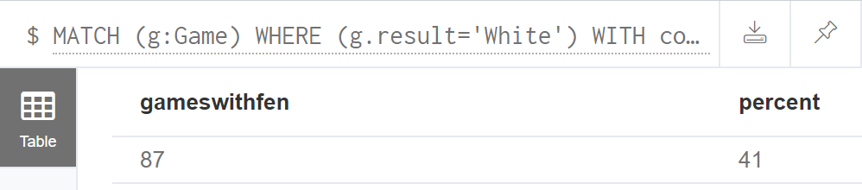

**Image 3:** **Screenshot Query 1**

* **Query 2:**

***For all games containing position FEN: r1bqkbnrpppp1ppp2n51B2p34P35N2PPPP1PPPRNBQK2R, how many times (count) won the white, won the black or the game was draw.***

* + Cypher Query:

**Table 5:Query 2**

|  |
| --- |
| **MATCH** ()-[r:MOVE]->(n2:Position)  **WHERE** n2.FEN ='r1bqkbnrpppp1ppp2n51B2p34P35N2PPPP1PPPRNBQK2R'  **WITH** collect(**DISTINCT**(r.gameNumber)) AS AVECFEN  **MATCH** (g**:**Game)  **WHERE** g.gameNumber **IN** AVECFEN  **UNWIND** g.result **AS** FinalResult  **RETURN** FinalResult,**COUNT**(g) **AS** NumberofGames |

* + Results:

**Table 6: Results Query 2**

|  |  |
| --- | --- |
| FinalResult | NumberofGames |
| White | 36 |
| Draw | 34 |
| Black | 17 |

* + Screenshot from Neo4J:

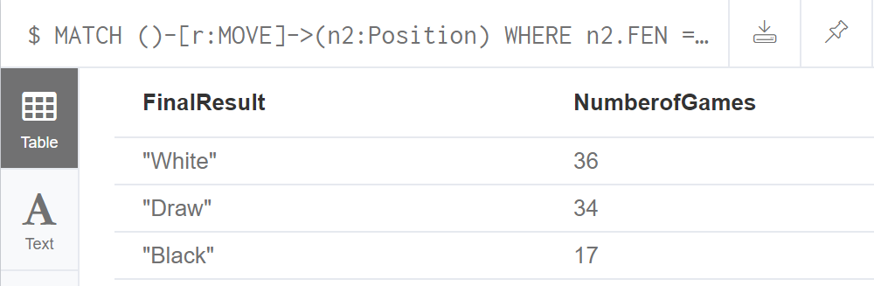

**Image 4: Screenshot Query 2**

* **Query 3:**

***Which was the event that had the most games, and in how many of these games had played “Karpov Anatoly” with white or black.***

* + Cypher Query:

**Table 7: Query 3**

|  |
| --- |
| **MATCH** (p:Game)-[r:CONTEXTOF]->(e:Event)  **UNWIND** e.event **AS** Ev  **WITH** Ev, COUNT(r) **AS** cnt  **ORDER BY** cnt **DESC**  **WITH** COLLECT([Ev, cnt]) **AS** events  **UNWIND** events **AS** EV  **WITH** EV  **WHERE** EV[1]=events[0][1]  **WITH** COLLECT(EV[0]) **AS** even  **MATCH** (p1:Game)-[r2:CONTEXTOF]->(e2:Event)  **WHERE** e2.event **IN** even  **WITH** COLLECT([p1.gameNumber, e2.event]) **AS** games  **UNWIND** games **AS** GM  **MATCH** (pl:Player)-[r3:PLAYED]->(g:Game)  **WHERE** pl.name='Karpov Anatoly' **AND** g.gameNumber **IN** GM[0]  **WITH** count(g.gameNumber) **AS** NumberofGamesAnatolyPlayed, GM[1] **AS** Event, games **AS** games  **UNWIND** games **AS** GM2  **WITH** GM2, NumberofGamesAnatolyPlayed,Event  **WHERE** GM2[1]=Event  **RETURN** Event, **count**(GM2[1]) **AS** Total_Games, NumberofGamesAnatolyPlayed |

* + Results:

**Table 8: Results Query 3**

|  |  |  |
| --- | --- | --- |
| Event | Total_Games | NumberofGamesAnatolyPlayed |
| World Championship 31th | 48 | 48 |

* + Screenshot from Neo4J:

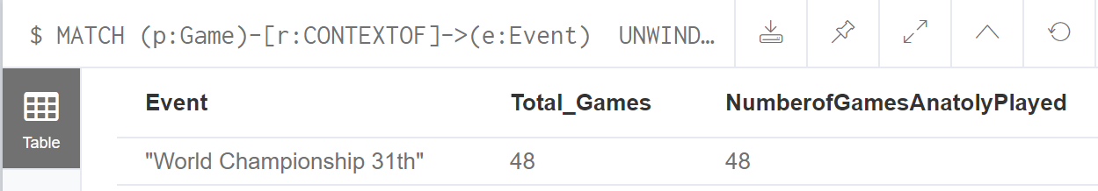

**Image 5: Screenshot Query 3**

* **Query 4:**

***Which player had played most games with “Ruy Lopez” opening.***

* + Cypher Query:

**Table 9: Query 4**

|  |
| --- |
| **MATCH** (a:Player)-[:PLAYED]->(g:Game)  **WHERE** g.opening='Ruy Lopez'  **RETURN** a.name **AS** name, count(a.name) as occurrences  **ORDER BY** occurrences **DESC**  **LIMIT** 1 |

* + Results:

**Table 10: Results Query 4**

|  |  |
| --- | --- |
| name | occurrences |
| Lasker Emanuel | 17 |

* + Screenshot from Neo4J:

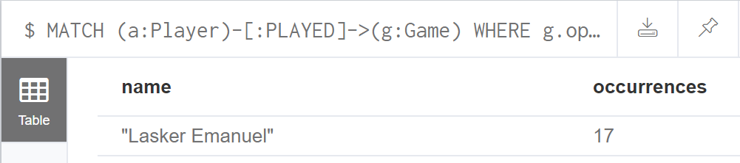

**Image 6: Screenshot Query 4**

* **Query 5:**

***How many games had the sequence of moves (in the exact order) “Nc6”, “Bb5”, “a6”, and which was the players of these games.***

* + Cypher Query:

**Table 11: Query 5**

|  |
| --- |
| **MATCH** ()-[r2:MOVE {move: 'Nc6'}]->()-[r3:MOVE {move: 'Bb5'}]->()-[r4:MOVE {move: 'a6'}]->()  **WITH** collect(**DISTINCT** r4.gameNumber) **as** moveordering  **MATCH** (p:Player)-[pl:PLAYED]->(g:Game)  **WHERE** g.gameNumber **in** moveordering  **RETURN** **count**(distinct(g.gameNumber)) **as** total_games_with_move_sequence, collect(DISTINCT(p)) **as** players |

* + Results:

**Table 12: Results Query 5**

|  |  |
| --- | --- |
| total_games_with_move_sequence | players |
| 52 | [{name:Korchnoi Viktor L},  {name:Karpov Anatoly},  {name:Botvinnik Mikhail M},  {name:Smyslov Vassily V},  {name:Bogoljubow Efim D},  {name:Alekhine Alexander A},  {name:Spassky Boris V},  {name:Fischer Robert J},  {name:Schlechter Carl},  {name:Lasker Emanuel},  {name:Petrosian Tigran V},  {name:Reshevsky Samuel H},  {name:Keres Paul},  {name:Tarrasch Siegbert},  {name:Euwe Max},  {name:Janowski Dawid M},  {name:Chigorin Mikhail I},  {name:Steinitz Wilhelm},  {name:Kasparov Gary}] |

* + Screenshot from Neo4J (1):

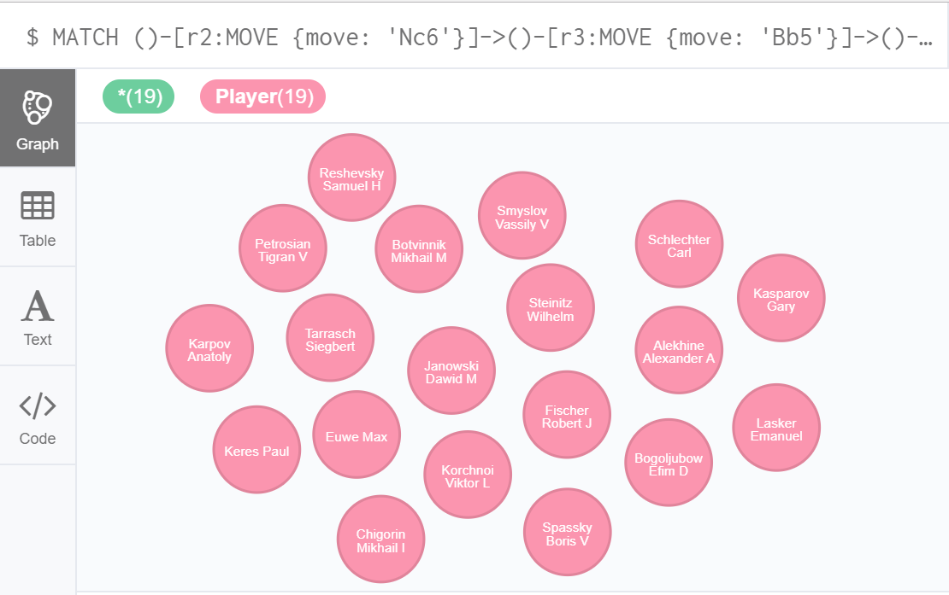

**Image 7: Names of players**

* + Screenshot from Neo4J (2):

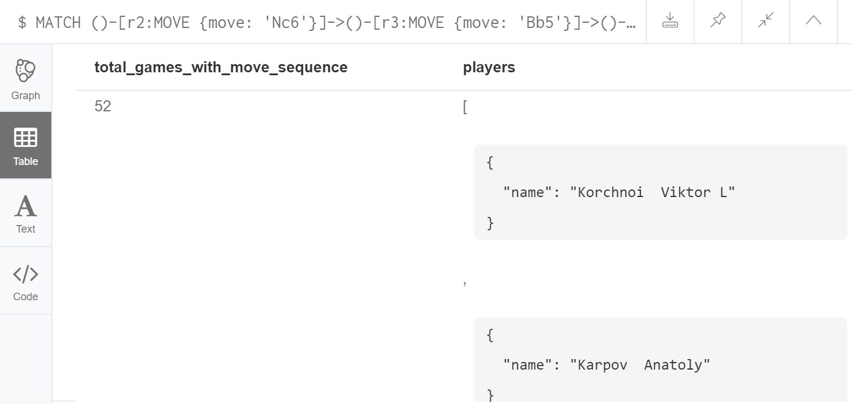

**Image 8: Screenshot Query 5**

* **Query 6:**

***Display all game details, event, players and moves of the game with GameNumber: 636.***

* + Cypher Query:

**Table 13: Query 6**

|  |
| --- |
| **MATCH** ()-[r1:MOVE]->(p1:Position)  **MATCH** (n:Game)-[c:CONTEXTOF]->(e:Event)  **MATCH** (p:Player)-[pl:PLAYED]->(n:Game)  **WHERE** r1.gameNumber = 636 and n.gameNumber = 636  **RETURN** n **as** game, r1 **as** move, p1 **as** positionaftermove, e **as** event, pl **as** color, p **as** player, n.opening **as** opening,n.result **as** result,n.moves **as** moves |

* + Results:

We don’t display the table here as the requested information is expanded in 162 (81 moves by 2 players) rows. Alternatively, the graph of the game is depicted below in Image 9 and zoomed in Image 10**Error! Reference source not found.** from the Neo4J platform.

* + Screenshot from Neo4J (1):

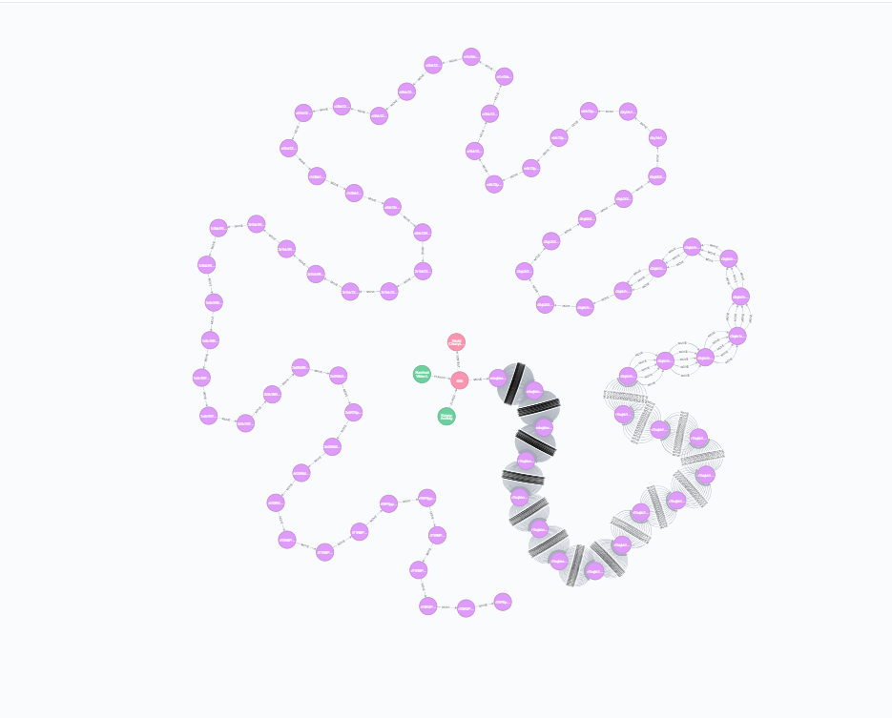

**Image 9: Graph of Game 636**

* + Screenshot from Neo4J (2):

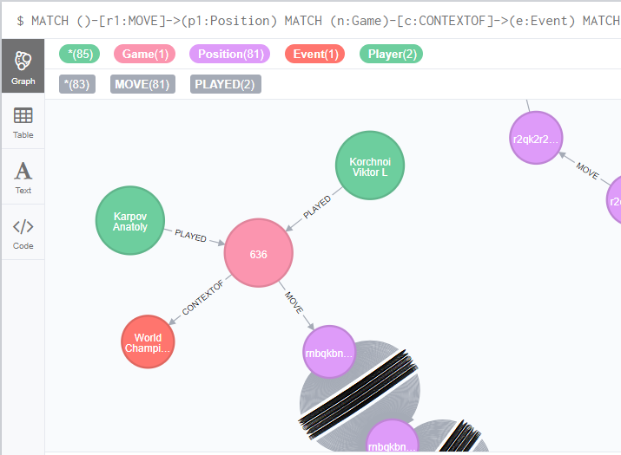

**Image 10: Game 636 zoomed**

* **Query 7:**

***Display all chess games that include the position with FEN: r1bqkbnrpppp1ppp2n51B2p34P35N2PPPP1PPPRNBQK2R and after this position the move “a6” was not played. Also display the alternative moves and the game result.***

* + Cypher Query:

**Table 14: Query 7**

|  |
| --- |
| **MATCH** (n1:Position{FEN:'r1bqkbnrpppp1ppp2n51B2p34P35N2PPPP1PPPRNBQK2R'})-[r2:MOVE]->()  **WHERE** r2.move<>'a6'  **WITH** collect([r2.gameNumber, r2.move]) AS results, r2.gameNumber **AS** gamenumbers  **UNWIND** results as games_alternative_moves  **MATCH** (g:Game)  where g.gameNumber **IN** games_alternative_moves  **RETURN** g.gameNumber **AS** GameNumber, g.result **AS** FinalResult, games_alternative_moves[1] as Alternative_Move  **ORDER BY** g.gameNumber **ASC** |

* + Results:

There were 35 chess games that included the position with FEN *'r1bqkbnrpppp1ppp2n51B2p34P35N2PPPP1PPPRNBQK2R'* and after this the move ‘a6’was not played. The respective chess games, the final results and the alternative moves are appearing in Table 15 below:

**Table 15: Results Query 7**

| GameNumber | FinalResult | Alternative_Move |
| --- | --- | --- |
| 4 | Black | Nf6 |
| 6 | White | Nf6 |
| 8 | Draw | Nf6 |
| 10 | Draw | Nf6 |
| 12 | White | Nf6 |
| 14 | Draw | Nf6 |
| 16 | White | Nf6 |
| 18 | White | Nf6 |
| 23 | White | d6 |
| 39 | Black | d6 |
| 58 | Draw | Nf6 |
| 60 | White | Nf6 |
| 67 | Black | d6 |
| 70 | White | Nf6 |
| 80 | White | d6 |
| 81 | White | Nf6 |
| 82 | White | d6 |
| 84 | Draw | d6 |
| 86 | White | d6 |
| 88 | White | d6 |
| 99 | Black | Nf6 |
| 115 | Black | Nf6 |
| 117 | Black | Nf6 |
| 121 | Draw | Nf6 |
| 123 | White | Nf6 |
| 125 | White | Nf6 |
| 127 | Draw | Nf6 |
| 129 | Black | Nf6 |
| 151 | Draw | Nf6 |
| 153 | Draw | Nf6 |
| 155 | White | Nf6 |
| 166 | Draw | Nf6 |
| 172 | Draw | Nf6 |
| 174 | Black | Nf6 |
| 620 | White | Nf6 |